Parth Kapur

**CS441 – Assignment 4 Individual Portion**

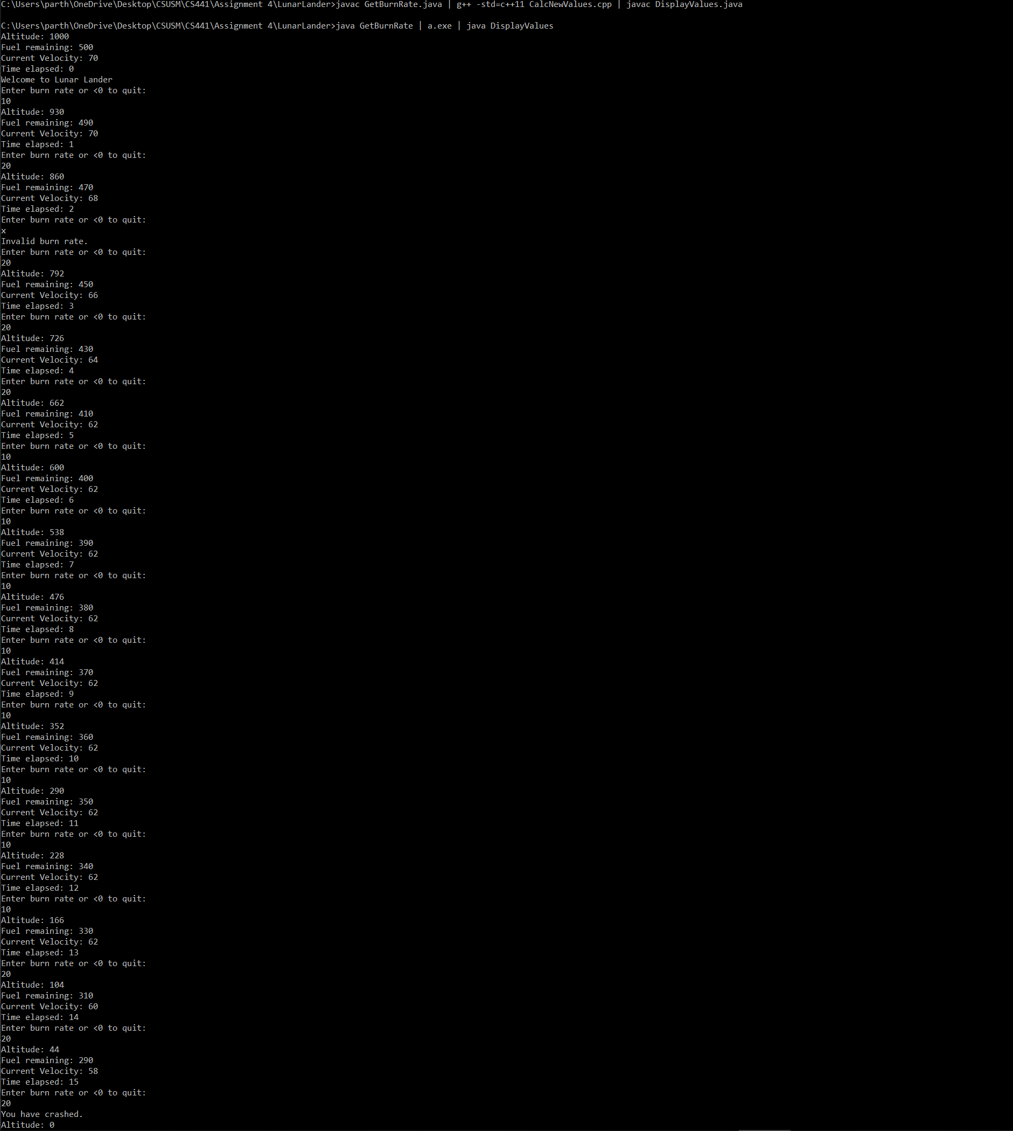

**Explanation**: This would work because Lunar Lander uses a pipe-and-filter architecture style. Essentially, this means that how the file was compiled does not matter, merely the output of the file. So, this is why we are able to compile two parts java & one parts c++, as the c++ portion of the files does not care about how the java code is running. The c++ portion of the file only cares about the output sent to it via the pipe-and-filter architecture. The framework being used is java.io & <iostream> (c++). These input and output stream methods allow for a user to enter data and the program to print out data to be handled by the next file.